Activity | The impact of choices

Forks in the road
If you know what you want, either generally or in fine detail, are you taking and making opportunities that advance your aims? Are you somebody who looks for the opportunities in whatever comes your way or are you more likely to wait, hoping for the perfect moment to arrive? In every moment of the day, we make decisions that create a ‘fork’ in the path of our life. By acting one way or another, or by not acting at all, we make a choice to move in one direction and not another.
In the example shown on the flowchart below, at 15, Paulette decided to leave her part-time job at a local shop and work part-time in an electronics company. At the time, she just wanted a ‘change of scene’ that allowed her more flexible hours. From that decision, she met new people, overcame a fear of ‘technical things’, and travelled to China. These changes affected her choice of subject and friends at university.
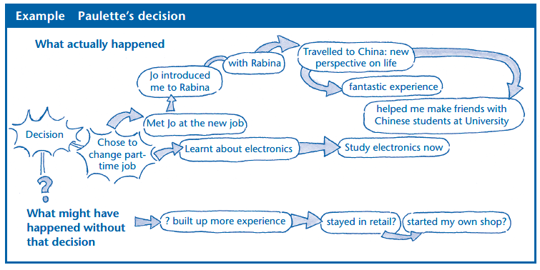
Have a go at these activities to consider the longer term impact of choices you have made.
Activity: The road walked
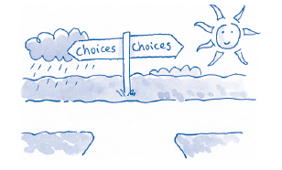
Take approximately three minutes to jot down choices you have made that you look back on and feel good about. This may include significant friendships, work, how you dealt with difficult situations, saying or doing the right thing, presents given, offers that you accepted or turned down, your dedication to your learning or to resolving a problem, the benefits from learning a new skill, acts of kindness, and good decisions you made. Focus on your role – what you did or did not do – rather than on what others did to you.

Read through your list and select your best use of an opportunity. It may appear small, such as giving somebody a card and seeing their face light up, or it may have been a major event such as saving a life.

Take a piece of paper and write the example at the top of the paper, as in the example above under ‘Paulette’s decision’. Spend a few minutes jotting down the various impacts of that one occasion on other aspects of your life. What opportunities, large or small, arose for you from seizing that first opportunity?

Activity: The road unwalked
Now take approximately five minutes to brainstorm all the decisions you look back on and feel less good about. This may include opportunities that were present that you did not recognise at the
time. For example, as well as the items on the above list, you may consider the things you did not do, say or learn. Focus on your role – what you did or did not do – rather than on what others did to you.

Read through your list and select the one opportunity that you feel you missed that has had the greatest impact upon your life.

Take a piece of paper and write down this decision as in the example above (‘Paulette’s decision’). Spend a few minutes brainstorming all the ways that that one occasion has had an impact upon your life since. What other choices could you have made then? What might have been the consequences of making each of those other choices?

